**Dokumentácia hardvéru v RB303**

Obsah

1. Plán miestnosti 3

2. Elektrické zapojenie 4

2.1 Elektrické zapojenie racku 1 4

2.2 Elektrické zapojenie racku 2 5

2.3 Elektrické zapojenie racku 3 6

3. Zariadenia v rackoch 7

3.1 Rack 1 7

3.2 Rack 2 8

3.3 Rack 3 9

# 1. Plán miestnosti

Nasledujúci obrázok ilustračne zobrazuje miestnosť RB303. Všetky 3 racky sú umiestnené ihneď pri hlavnom vstupe do miestnosti. Sú očíslované tak, ako na ne budeme odkazovať v ďalších častiach dokumentu.

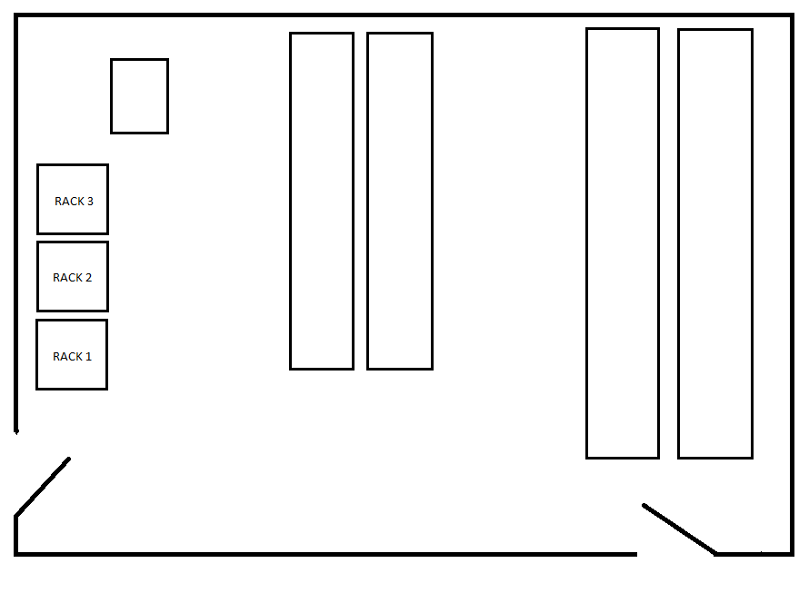

# 2. Elektrické zapojenie

V nasledovných troch kapitolách je schematicky zobrazené elektrické zapojenie jednotlivých zariadení v racku do elektrických zásuviek.

## 2.1 Elektrické zapojenie racku 1

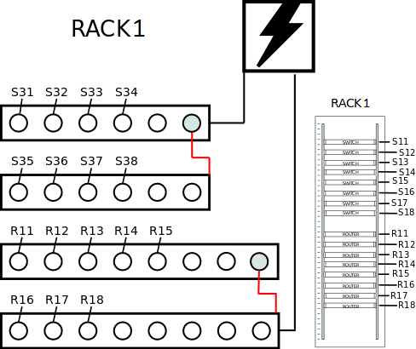

## 2.2 Elektrické zapojenie racku 2

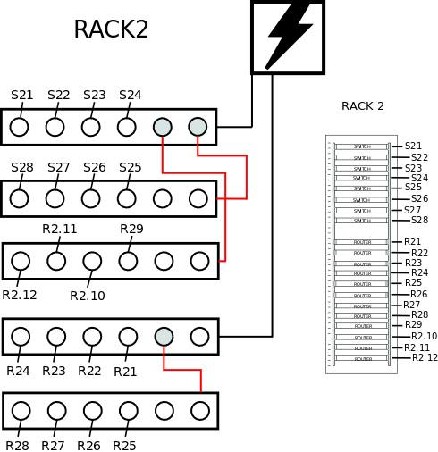

## 2.3 Elektrické zapojenie racku 3

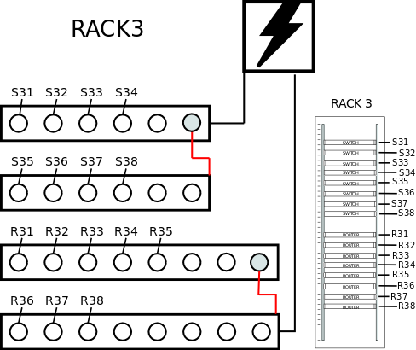

# 3. Zariadenia v rackoch

V tejto časti sú popísané kompletne všetky zariadenia v jednotlivých rackoch, pričom ku každému z nich uvádzame aktuálne nainštalovanú verziu IOS, kapacitu operačnej pamäte a fyzické porty, ktorými dané zariadenie disponuje.

## 3.1 Rack 1

|  |  |  |  |  |
| --- | --- | --- | --- | --- |
| **Pozícia v racku** | **Zariadenie** | **Verzia IOS** | **Kapacita RAM** | **Porty** |
| 30 |  |  |  |  |
| 29 | patch panel | - | - | - |
| 28 |  |  |  |  |
| 27 |  |  |  |  |
| 26 | Catalyst 3550 | 12.2 (44) SE6 | 72 MB | 24x FastEthernet, 2x Gigabit Ethernet |
| 25 | Catalyst 3550 | 12.2 (44) SE6 | 72 MB | 24x FastEthernet, 2x Gigabit Ethernet |
| 24 | Catalyst 2960 | 12.2 (58) SE1 | 64 MB | 24x FastEthernet, 2x Gigabit Ethernet |
| 23 | Catalyst 2960 | 15.0 (2) SE5 | 64 MB | 24x FastEthernet, 2x Gigabit Ethernet |
| 22 |  |  |  |  |
| 21 | Catalyst 3550 | 12.2 (44) SE6 | 72 MB | 24x FastEthernet, 2x Gigabit Ethernet |
| 20 | Catalyst 3550 | 12.2 (44) SE6 | 72 MB | 24x FastEthernet, 2x Gigabit Ethernet |
| 19 | Catalyst 2960 | 12.2 (44) SE5 | 64 MB | 24x FastEthernet, 2x Gigabit Ethernet |
| 18 | Catalyst 2960 | 12.2 (58) SE1 | 64 MB | 24x FastEthernet, 2x Gigabit Ethernet |
| 17 |  |  |  |  |
| 16 |  |  |  |  |
| 15 | Cisco 1841 rev. 6.0 | 15.5 (2) XB | 384 MB | 2x FastEthernet, 2x Serial, 1x ISDN |
| 14 | Cisco 1841 rev. 7.0 | 15.5 (2) XB | 384 MB | 2x FastEthernet, 4x Serial |
| 13 | Cisco 1841 rev. 7.0 | 12.4 (13r) T5 | 384 MB | 2x FastEthernet, 4x Serial, 1 VPN |
| 12 | Cisco 1841 rev. 6.0 | 12.4 (13r) T5 | 384 MB | 2x FastEthernet, 4x Serial, 1x VPN |
| 11 | Cisco 1841 rev. 6.0 | 15.5 (2) XB | 384 MB | 2x FastEthernet, 2x Serial, 2x Low-Speed Serial, 1x VPN |
| 10 | Cisco 2811 rev. 1.0 | 15.3 (3) XB12 | 768 MB | 6x FastEthernet, 2x Serial, 2x ISDN, 1x VPN |
| 9 | Cisco 2811 rev. 1.0 | 15.3 (13r) T11 | 768 MB | 6x FastEthernet, 2x Low-Speed Serial, 1x ISDN, 1x VPN |
| 8 | Cisco 2811 rev. 1.0 | 12.4 (13r) T11 | 768 MB | 11x FastEthernet, 2x Serial, 2x Chanelized E1/PRI, 1x VPN |
| 7 |  |  |  |  |
| 6 |  |  |  |  |
| 5 |  |  |  |  |
| 4 |  |  |  |  |
| 3 |  |  |  |  |
| 2 |  |  |  |  |
| 1 |  |  |  |  |

## 3.2 Rack 2

|  |  |  |  |  |
| --- | --- | --- | --- | --- |
| **Pozícia v racku** | **Zariadenie** | **Verzia IOS** | **Kapacita RAM** | **Porty** |
| 30 |  |  |  |  |
| 29 | patch panel | - | - | - |
| 28 |  |  |  |  |
| 27 |  |  |  |  |
| 26 | Catalyst 3550 | 12.1 (13) EA1a | 72 MB | 24x FastEthernet, 2x Gigabit Ethernet |
| 25 | Catalyst 3550 | 12.1 (20) EA1 | 72 MB | 24x FastEthernet, 2x Gigabit Ethernet |
| 24 | Catalyst 2960 | 12.2 (58) SE1 | 72 MB | 24x FastEthernet, 2x Gigabit Ethernet |
| 23 | Catalyst 2960 | 12.2 (58) SE1 | 72 MB | 24x FastEthernet, 2x Gigabit Ethernet |
| 22 |  |  |  |  |
| 21 | Catalyst 3550 | 12.2 (44) SE6 | 72 MB | 48x FastEthernet, 2x Gigabit Ethernet |
| 20 | Catalyst 3550 | 12.2 (44) SE6 | 72 MB | 48x FastEthernet, 2x Gigabit Ethernet |
| 19 | Catalyst 2960 | 12.2 (44) SE5 | 64 MB | 24x FastEthernet, 2x Gigabit Ethernet |
| 18 | Catalyst 2960 | 15.0 (1) SE2 | 64 MB | 24x FastEthernet, 2x Gigabit Ethernet |
| 17 |  |  |  |  |
| 16 |  |  |  |  |
| 15 | Cisco 1841 rev. 6.0 | 15.5 (2) XB | 384 MB | 2x FastEthernet, 2x Serial, 1x ISDN, 1x VPN |
| 14 | Cisco 1841 rev. 6.0 | 15.5 (2) XB | 384 MB | 2x FastEthernet, 4x Low-Speed Serial, 1x VPN |
| 13 | Cisco 1841 rev. 7.0 | 15.5 (2) XB | 384 MB | 2x FastEthernet, 2x Low-Speed Serial, 2x Chanelized E1/PRI, 1x VPN |
| 12 | Cisco 1841 rev. 5.0 | 12.4 (13r) T5 | 384 MB | 2x FastEthernet, 2x Serial, 1x VPN, 1x DSL |
| 11 | Cisco 2811 rev. 3.0 | 12.4 (13r) T11 | 512 MB | 15x FastEthernet, 2x Low-Speed Serial, 1x VPN |
| 10 | Cisco 2811 rev. 3.0 | 15.3 (3) XB12 | 512 MB | 6x FastEthernet, 2x Low-Speed Serial, 1x Chanelized E1/PRI, 1x VPN |
| 9 | Cisco 2811 rev. 1.0 | 15.3 (13r) T12 | 512 MB | 2x FastEthernet, 1x VPN |
| 8 | Cisco 2811 rev. 1.0 | 15.3 (3) XB12 | 768 MB | 2x FastEthernet, 4x Serial, 16x Low-Speed Serial, 1x ISDN, 1x VPN |
| 7 | Catalyst 3550 | 12.2 (44) SE6 | 72 MB | 24x FastEthernet, 2x Gigabit Ethernet |
| 6 | Catalyst 3550 | 12.2 (44) SE6 | 72 MB | 24x FastEthernet, 2x Gigabit Ethernet |
| 5 | Catalyst 2950 | 12.1 (22) EA14 | 16 MB | 24x FastEthernet, 2x Gigabit Ethernet |
| 4 | Catalyst 2950 | 12.1 (22) EA14 | 16 MB | 24x FastEthernet, 2x Gigabit Ethernet |
| 3 |  |  |  |  |
| 2 |  |  |  |  |
| 1 |  |  |  |  |

## 3.3 Rack 3

|  |  |  |  |  |
| --- | --- | --- | --- | --- |
| **Pozícia v racku** | **Zariadenie** | **Verzia IOS** | **Kapacita RAM** | **Porty** |
| 30 |  |  |  |  |
| 29 | patch panel | - | - | - |
| 28 |  |  |  |  |
| 27 |  |  |  |  |
| 26 | Catalyst 3550 | 12.1 (14) EA1a | 72 MB | 24x FastEthernet, 2x Gigabit Ethernet |
| 25 | Catalyst 3550 | 12.2 (44) SE6 | 72 MB | 24x FastEthernet, 2x Gigabit Ethernet |
| 24 | Catalyst 2960 | 15.0 (2) SE5 | 64 MB | 24x FastEthernet, 2x Gigabit Ethernet |
| 23 | Catalyst 2960 | 12.2 (58) SE2 | 64 MB | 24x FastEthernet, 2x Gigabit Ethernet |
| 22 |  |  |  |  |
| 21 | Catalyst 3550 | 12.2 (44) SE6 | 72 MB | 24x FastEthernet, 2x Gigabit Ethernet |
| 20 | Catalyst 3550 | 12.2 (44) SE6 | 72 MB | 24x FastEthernet, 2x Gigabit Ethernet |
| 19 | Catalyst 2960 | 12.2 (58) SE2 | 64 MB | 24x FastEthernet, 2x Gigabit Ethernet |
| 18 | Catalyst 3550 | 12.2 (44) SE6 | 72 MB | 24x FastEthernet, 2x Gigabit Ethernet |
| 17 |  |  |  |  |
| 16 |  |  |  |  |
| 15 | Cisco 1841 rev. 5.0 | 15.5 (2) XB | 384 MB | 2x FastEthernet, 2x Low-Speed Serial, 1x ISDN, 1x VPN |
| 14 | Cisco 1841 rev. 7.0 | 15.5 (2) XB | 384 MB | 6x FastEthernet, 2x Low-Speed Serial, 1x VPN |
| 13 | Cisco 1841 rev. 6.0 | 15.5 (2) XB | 384 MB | 6x FastEthernet, 2x Serial, 1x VPN |
| 12 | Cisco 1841 rev. 7.0 | 15.5 (2) XB | 384 MB | 6x FastEthernet, 2x Low-Speed Serial, 1x VPN |
| 11 | Cisco 2811 rev. 6.0 | 15.5 (2) XB | 384 MB | 6x FastEthernet, 2x Low-Speed Serial, 1x VPN |
| 10 | Cisco 2801 rev. 7.0 | 15.3 (3) XB12 | 384 MB | 2x FastEthernet, 2x Low-Speed Serial, 1x VPN |
| 9 | Cisco 2801 rev. 7.0 | 15.3 (3) XB12 | 384 MB | 2x FastEthernet, 2x Low-Speed Serial, 1x VPN |
| 8 | Cisco 2801 rev. 7.0 | 15.3 (3) XB12 | 384 MB | 6x FastEthernet, 2x Low-Speed Serial, 1x VPN |
| 7 |  |  |  |  |
| 6 |  |  |  |  |
| 5 |  |  |  |  |
| 4 |  |  |  |  |
| 3 |  |  |  |  |
| 2 |  |  |  |  |
| 1 |  |  |  |  |